Using Design Thinking to Support Participatory Problem Finding

Introduction
This resource informs the Needs Analysis approach for the research project - Development of Sustainable Physical Activity and Nutrition Intervention Tools within a Low Resourced Community. The research project will take place in collaboration with community members of Ikageng, Tlokwe, South Africa and research colleagues from the North-West University, Potchefstroom, South Africa; Turku University of Applied Science, Finland; and the University of British Columbia, Canada.

The objective of this research project is to determine the physical activity and nutrition needs of a low resourced community in order to develop and implement a sustainable community project on the back of a mobile platform. The intent is to change attitudes and behaviour towards physical activity participation and nutrition choices. Further, the collaborators recognize that South Africa is a unique setting with unique requirements. Therefore the interventions and education should be aimed to meet the unique challenges and opportunities of South Africa.

It must be noted that health issues related to a lack of physical activity and poor nutrition are not unique to South Africa. The World Health Organization (WHO) suggests that globally nearly one third of adults are inactive, and this number is raising. Poverty, and its inherent lack of food security, further impacts the health of people living marginalized, increasingly urban lifestyles.

The UN Sustainable Millennium Goals, specifically Goals Two and Three, add support and urgency to our work (http://www.un.org/sustainabledevelopment/sustainable-development-goals/). In starting this research project, we know that lasting change comes from the community in which the change is needed. The adage, “Nothing about us without us!” guides our Need Analysis approach, and we draw highly from the traditions of Participatory Design, Collective Impact, and Design Thinking.

Table of Contents

- Background to the Approach
  - What Is Design Thinking?

1.2 Design Thinking’s Origins

1.3 Design Thinking as a Research Methodology

- The Design Thinking Process
2.1 Learning to Ask Good Questions

2.2 Using Design Thinking for Research
2.2.1 Before You Start the Design Thinking Process
2.2.2 Steps in the Design Thinking Process

2.3 Moving from Ideation to Prototyping
- Components of a Good Design Challenge
3.1 Tips on Crafting Design Challenge Components

- Makerspaces by Maker / Prototype Intentions and Safety Issues

- References
Appendix 1 – Tips for Making, Fastening, and Materials and Resources by Intentions
Suggestions and Rationale by Intention

Appendix 2 – Sample Design Challenges

Appendix 3 - Tips for Facilitating a Design Thinking Research Session

- Background to the Approach

1.1 What Is Design Thinking?
Design thinking is a human-centred process honed at Stanford University’s d.School (https://dschool.stanford.edu/). The process is used in business, schools, organizations and numerous other settings to create change and foster innovation. Design thinking, as a process, encourages participants to develop a positive, proactive and optimistic stance toward addressing complex problems.

Design thinking supports divergent, lateral thinking – thinking that enables problem finding rather than quick, often short sighted, problem solving. Using design thinking, users come to realize it is possible “… to creatively attack the world’s greatest problems and meet people’s most urgent needs” (Hatch, 2014). Sites like Open IDEO.org share wonderful projects that people have tackled – all in the service of the public good.

Design thinking can be used to develop eight core abilities:
- Navigate ambiguity - ability to persist with the discomfort of not knowing
- Learn from others – ability to emphasize and embrace diversity
- Synthesize information – ability to make sense of information and find insight and opportunity
- Experiment rapidly – ability to quickly generate ideas in written, drawn or built forms
- Move between concrete and abstract – ability to move between needs, ideas, and define ideas
- Build and craft intentional – ability to thoughtfully make / construct ideas into tangible, shareable forms
- Communication deliberately – ability to form, capture, and related stories, ideas, concepts, reflections and learnings to diverse audiences
- Design – ability to recognize a project as a design challenge and then decide on people, tools, techniques required to tackle it (https://dschool.stanford.edu/about/#about-8-core-abilities).

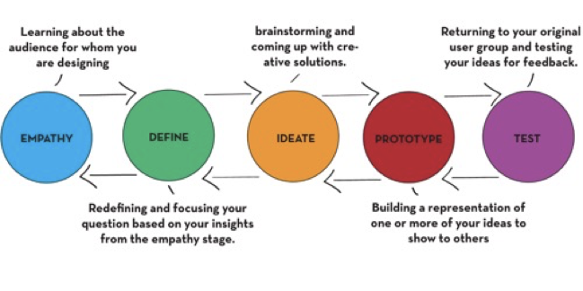
As described by d.School, design thinking has five steps
According to Tim Brown, CEO of IDEO (www.ideo.org), becoming a design thinker helps us
- Gain empathy for others and imagine the world from multiple perspectives
- Engage in integrative thinking and learn to exploit the potential of various ideas and constraints to create something new
- Maintain and gain optimism, suggesting no matter how challenging the constraints of a given problem, at least one potential solution is better than the existing alternatives
- Engage in experimentalism by posing questions and exploring constraints in creative ways that proceed in entirely new directions
- Collaborate with others, recognizing the strength of the Japanese proverb that none of us are as smart as all of us.

1.2 Design Thinking’s Origins
The Interaction Design Foundation (https://www.interaction-design.org/literature/article/design-thinking-get-a-quick-overview-of-the-history) provides an overview of the history / evolution of design thinking, dating back to initial attempts in the 1960s to turn design into a process. This effort corresponded with Buckminster Fuller’s call for a “‘design science revolution', based on science, technology and rationalism, to overcome the human and environmental problems that he believed could not be solved by politics and economics" (Cross, 2001). At this same time, Horst Rittel,

a Design Theorist known for coining the term ‘Wicked Problems’ (i.e. extremely complex/multi-dimensional problems) … wrote and spoke extensively on the subject of problem-solving in design. In particular, Rittel focused on the application of design methodologies in tackling Wicked Problems and how they were influential in the work of many design practitioners and academics of the time. Wicked problems are at the very heart of Design Thinking, because it is precisely these complex and multi-dimensional problems that require a collaborative methodology that involves gaining a deep understanding of humans (Dam & Siang, n.d.).
During the 1970s and 1980s,
Cognitive scientist and Nobel Prize laureate for economics, Herbert Simon, … contributed many ideas that are now regarded as tenets of Design Thinking … . He is noted to have spoken of rapid prototyping and testing through observation, concepts which form the core of many design and entrepreneurial processes right now. This also forms one of the major phases of the typical Design Thinking process. … A large portion of his work was focused on the development of artificial intelligence and whether human forms of thinking could be synthesized.
Robert H. McKim, best described as an artist and engineer, focused his energies more on the impact visual thinking … and design methods for solving problems with an emphasis on combining the left and right brain modes of thinking, to bring about a more holistic form of problem solving.
In 1982, Nigel Cross discussed the nature of designers problem-solving in his seminal paper Designerly ways of knowing. ... Cross compared designers’ problem solving to the non-design related problem solutions we develop in our everyday lives (Dam & Siang, n.d.).
In 1991, IDEO was formed and featured a design process modeled on the work developed at the Stanford Design School.
IDEO is widely accepted as one of the companies that brought Design Thinking to the mainstream; developing their own customer-friendly terminology, steps, and toolkits over the years, they have allowed those not schooled in design methodology to quickly and easily become oriented with the process.
[Currently,] Design Thinking is taught at the Stanford School of Design, or the d.school.
At present, the Design Thinking movement is gaining ground rapidly, with pioneers like IDEO and d.school formalizing a path ahead for others to follow. Other prestigious universities, business schools and forward thinking companies have adopted the methodology to varying degrees, sometimes re-interpreting it to suit their specific context or brand values (Dam & Siang, n.d.).
  - Design Thinking as a Research Methodology
As a research methodology, design thinking can be found in the work of participatory design (https://medium.com/the-making-of-appear-in/participatory-design-as-a-research-method-bc42c01943b1) and Collective Impact (https://ssir.org/articles/entry/collective_impact). Both these approaches place the individuals being studied at the heart of the work and views them as participants in both the process and product. Both Participatory Design and Collective Impact include participants in all aspects of the research from setting the research agenda and questions to determining metrics for evaluation and terms for data analysis. Section 2.2.1 in this resource shares a tested method used in design thinking research methodologies.
Design thinking is well suited for research questions that are complex by nature and wicked. Wicked problems do not refer to mean problems but rather are problems that seem impossible to solve – problems like the majority of the United Nations Sustainable Millennium Goals. Ten characteristics of wicked problems include
- There is no definitive formula for a wicked problem.
- Wicked problems have no stopping rule, as in there’s no way to know your solution is final.
- Solutions to wicked problems are not true-or-false; they can only be good-or-bad.
- There is no immediate test of a solution to a wicked problem.
- Every solution to a wicked problem is a "one-shot operation"; because there is no opportunity to learn by trial-and-error, every attempt counts significantly.
- Wicked problems do not have a set number of potential solutions.
- Every wicked problem is essentially unique.
- Every wicked problem can be considered a symptom of another problem.
- There is always more than one explanation for a wicked problem because the explanations vary greatly depending on the individual perspective.
- Planners/designers have no right to be wrong and must be fully responsible for their actions (Wicked Problems, n.d.).

- The Design Thinking Process

Stanford’s five step design thinking process start with gaining empathy for a challenge or situation through open questioning and interviews with individuals who are dealing directly with the challenge or situation. Design thinking seeks to gain empathy for a situation by developing understanding of the concerns, insights, lived experiences, and / or needs of others through interviews / questioning.

At the heart of good interviews are great questions – questions that are open, engaging and politely probing. It is through open questions that the person who is being interviewed can share what they are comfortable sharing and become engaged in a conversation that is rich and illuminating to both the interviewer and the interviewee.

2.1 Learning to Ask Good Questions

Learning to ask good questions is an outcome of the design thinking process. People working in the fields of coaching and leadership (Whitworth, Kimsey-House & Sandahl, 1998; Payne & Hagge, 2009) suggest powerful questions support open discussion and sustained dialogue. Their work is modified and shared in the table below.

Opening Questions  What is your intention?  What impact might this have?  What are some other possibilities?  What other ideas do you have about it? | Clarifying Questions  What do you mean? Please tell me more.  What concerns you most about this?  What concerns do you still have?  What more can you tell me?
Probing Questions  Can you give me an / another example?  What have you tried so far?  How did that work?  What might be missing? | Options  What are other possible solutions?  What would you like to see happen next?  What else could you do?  What other opportunities are there for this?
Action Questions  What are your next steps?  What are you willing to do to refine this?  What strengths do you see with this?  What would be helpful in assisting you? | Blocks / Barriers  What got in the way?  What if this doesn’t work, initially?  What’s your backup plan?  Are you prepared to take this further?

2.2 Using Design Thinking for Research

The design thinking process typically starts with a real-world challenge. Rather than hurrying to find a quick solution or trying to immediately replicate generalized solutions, the design thinking process is used to find and identify the source of the challenge by engaging with the people experiencing it and experiencing the factors that created it. The design thinking process is especially valuable to investigate complex or wicked research problems.

An example of a complex or wicked problem might be:

How might understanding the components of a healthy meal assist families in preparing and eating foods that support active, healthy living? Further, what barriers do families in extreme poverty face in attempting to prepare and consume meals that support active, healthy living?

Please see Section 3 which focuses on how to craft complex or wicked research questions in the form of a Design Challenge. Section 2.2.1 and 2.2.2 offers a tested approach for using design thinking in a research context. The approach below is a modification of the d.School process, and it uses a minimal amount of resources and materials. For an understanding of the actual d.School approach for design thinking, please explore The Gift-Giving Project (https://dschool-old.stanford.edu/groups/designresources/wiki/ed894/the_giftgiving_project.html) as it provides materials, resources, and video guide.

2.3 Moving from Ideation to Prototyping
The design thinking process allows participants to work together to create new ideas, products, ways of working, research, etc. The fourth step of the design thinking process, Prototyping, takes the good thinking from the first three steps (empathy, define, ideation) and makes tangible representations of the participants’ thinking. One might argue that it is through the ideation, prototyping and testing steps that Design Thinking comes into its own as a powerful, collaborative methodology.
It is through collective prototyping that participants begin to make their thinking visible (Eisner, 1998). Prototypes can take the forms of posters or sketches, but often participants are given tools and materials that allow them to make three dimensional objects. When tools and materials are included, often groups work in a makerspace where they can access shared equipment. Makerspaces do not need to be complete shop environments, and the following section offers some examples of the various intents and equipment one might consider when developing a mobile or stationary makerspace.

- Components of a Good Design Challenge
As stated in Section 2.2, the design thinking process is especially valuable to investigate complex or wicked research problems. The following example was offered as a complex or wicked problem prompting our research study

How might understanding the components of a healthy meal assist families in preparing and eating foods that support active, healthy living? Further, what barriers do families in extreme poverty face in attempting to prepare and consume meals that support active, healthy living?

Based on five years of research and practice, the Innovative Learning Centre (ILC) has refined its Design Challenge structure to incorporate five components. The ILC has learned that each of the components provides enough structure to create an even starting point for research participants. The ILC also recognizes that Design Challenges need to be open enough to invite multiple perspectives, insights and solutions while structured enough to provide support and initial direction. The Design Challenge bridges personal experience with existing situation (ie, policy, practices, research, etc.).

Crafting a design challenge is the same whether you start with a complex or wicked problem or a research question or questions. Each component of the structure is essential and interrelated.
It is not necessary to start writing the components in the order in which they will ultimately appear in the design challenge. Experience suggests as you write each component, the other components will need to be modified and edited to reflect changes in information or intent.

The ILC design challenge format consists of the following components:

- Overview Statement - provides the background for the challenge
- Design Rationale - provides the authentic context for why the challenge is important and connects the actual challenge to the participants by situating it within their context and lived experiences
- Problem Scenario - invites participants into the challenge and explains their group’s role and reason for involvement in addressing the challenge.
- Success Determinants - provides the criteria for how the information that is shares and the solutions that will be surfaced will be assessed / or analyzed during the group sharing
- Parameters – provides the rules and limitations groups have to follow or adhere to and they explain the opportunities, constraints, rules, requirements to use the materials, resources, tools available during the design thinking process.
3.1 Tips on Crafting Design Challenge Components

Overview
- Typically, it is very short and subtlety positions the challenge within what the students have already know (previous curriculum or field trips or shared experiences).
- The introduction makes the challenge real by situating it within current events, history, your community, etc.
- Depending on the literacy levels and Internet access of the participants, web links can be provided that link the challenge to existing content / resources.
Design Rationale
- In this section, new information / content can be introduced.
- If there are local experts you can invite into the design thinking session or ask participants to follow up with, this is where you could list / name them. Local experts could be extremely valuable as the participants can interview them to gain further empathy and understanding of the challenge.
- Linking to Ted Ed (http://ed.ted.com/) and other sources of expertise on timely topics can enhance participants understand of the significance of the challenge in which they are engaging.
Problem Scenario
- Everyone loves a good story. Scenarios provide a narrative that helps participants move from merely thinking about concepts in an abstract sense (theoretical knowledge) to feeling about the concepts and applying them in real or concrete applications.
- It helps participants to shift from passively reading about / thinking about information to doing something with the information.
- When actively creating their own knowledge about complex things, participants begin to form their own questions, recognizing that learning is not merely about answers, it is about GREAT questions.
Success Determinants
- Design thinking and making engage participants in a process that tends to lead to a product.
- Tips as to expectations and possibilities are important for reluctant or vulnerable participants who might be unsure as to what is possible. Some times when situations are too open, creatively and good thinking is stymied if participants of afraid of being wrong. Design loves constraint, and the more vulnerable the population, often the less they are able to take risks
Parameters
- They set the ground rules for working within the challenge. For example, this section might tell participants what they have to use or do to create common experience – i.e. participants to have to use something of everything in a group kit that is provided while they have an option to use things in a shared pantry of consumable items. Constraints like this promote divergent, lateral thinking.
- Participants should be directed to a Safety Station where they can be shown the proper way to use the tools and materials available during the challenge, depending on the tools, materials and resources available. Appendix 1 – Tips for Making, Fastening, and Materials and Resources by Intentions Suggestions and Rationale by Intention

- Makerspaces by Maker / Prototype Intentions and Safety Issues
The introduction of makerspaces into some schools, universities and community settings has added pressure for many site administrators and managers. Groups have raced to purchase what they believe is essential equipment – 3d printers and extensive CNC machines and circuity to support robotics and coding, etc. Equipment such as this is valuable, and it adds additional elements of supervision, safety and maintenance and facilitator support to a makerspace.

Adding a makerspace to sites does not necessarily mean you must add a complete shop environment. It does, however, require organizers to consider the intended use of the space and the intention of the making that will take place there. The ILC has consulted on the design and equipping of makerspaces from the most sophisticated one located at UBC Okanagan to the simplest one that is mobile and used in a school in a refugee camp situation in northern Uganda. The first step is considering the intended use of the makerspace. The following learning offer a guide for the equipment and materials that might be found in a range of makerspace environments. Appendix 1 – Tips for Making, Fastening, and Materials and Resources by Intentions offers suggestions for items that could be purchased or found to equipment makerspaces based on prototyping intentions.
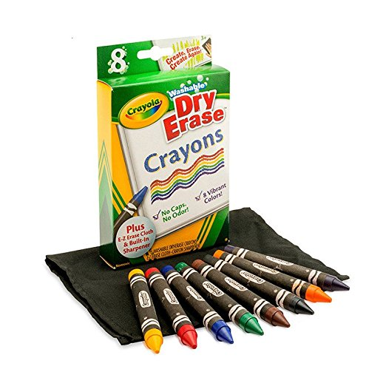
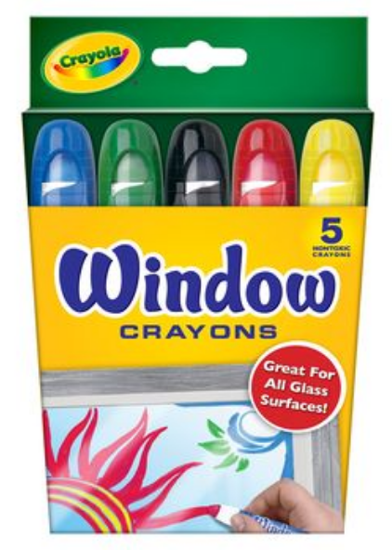
Common to most effective makerspaces is a collaborative space where people can come together to engage in design thinking, prototype ideas and share their ideas in a supportive, welcoming environment. The book Makespace: How to Set the Stage for Creative Collaboration by Scott Doorley and Scott Witthoft documents the wonderfully inviting and simple collaborative spaces developed by colleagues at Stanford’s d.School. The book provides tips, schematic drawings and suggestions for making collaborative spaces and utilizing simple materials and resoruces. Using wall spaces as drawing spaces, sketching is washable crayons and chalk help to make thinking visible and shared. The experiences from the ILC tells us that visuals, open spaces, and writeable surfaces help to encourage openness and collaboration. A favorite tool of ours areCrayola Window and dry erase crayons which allow all surfaces to be drawing surface.

NOTE: I’ll bring some of these with me along with a copy of the Makespace book

Complex to Simple  Expensive to Inexpensive   Advanced to Introductory | Maker / Prototype Intention | Description | Basic Tools | Basic Materials
 | Design and Basic Making | Introduction of design thinking and the making of simple, tangible items to illustrate design ideas in 3d | Hand tools, including glue guns, rulers, knives, scissors, etc. | Cardboard, recycling, simple found or purchased items (buttons, sticks, fabric, etc.)
 | Design and Simple Prototyping | Introduction and continued use of design thinking and more elaborate prototyping of ideas to scale | Hand tools and simple power tools such as Dremel tools, electric drills, etc. | Cardboard, recycling, simple found or purchased items with additional of Styrofoam, plastic pipe and fittings and other materials that can easily cut and fastened
 | Design and Fabrication | Use of design thinking and introduction of fabrication to create working prototypes at scale | Hand and power tools with option for 3d printers, CNC machines, etc. | Use of authentic materials
 | Design, Prototyping, Circuitry and Coding | Use of design thinking with the addition of coding and circuitry to add functionality to prototypes | Hand and power tools, soldering irons, circuits, breadboards, etc. | Use of authentic materials, including Arduino, circuits, etc.  Please see Microcomputing and Coding in Design Thinking for suggestions - (https://issuu.com/ubcedo/docs/diy_guidebook)

Regardless of the maker intent, the process of making starts with design thinking and the actual making is done during the prototype step of the process. Making without design is more hobby than process. While there is anything wrong with making as a recreational activity, stand-alone making does not honour the integrity and intent of the design thinking process. For more on the design of makerspaces, please consult Makespace (Doorley & Witthoft, 2012).

Safety is also a concern in makerspaces. Typically, makerspaces are facilitated environments with people available who know how to use the various pieces of equipment and ensure that there are adequate resources and materials for participants to use. The following is a suggestion for safety considerations in relation to makerspace intentions.

Complex to Simple  Expensive to Inexpensive   Advanced to Introductory | Maker / Prototype Intention | Basic Tool | Initial Safety Concerns
 | Design and Basic Making | Hand tools, including glue guns, rulers, knives, scissors, etc.) | Emphasis is on accurate measuring and safe cutting and careful assembly.  Use of ruler both for measuring and as a straight edge to cut against  Safe ways to walk holding sharp objects  Safe ways to use hot elements like glue guns and hot glue  Ways to help your group members – where to stand, how to hold things, use of tools with and among other people
 | Design and Simple Prototyping | Hand tools and simple power tools such as Dremel tools, power drills, etc. | Focus is on accurate measuring and safe cutting and careful assembly; emphasis is on selection of the appropriate tool for the task.  See bulleted list above  Use of v blocks and clamps to hold materials prior to drilling, cutting or shaping  Use of eye and ear protection for user and those immediately around them  Use of gloves – where appropriate  Use of drill bits and Demel attachments  Use of extension cords, cables, power bars, etc.  Ways to help your group members – where to stand, how to hold things, use of tools with and among other people
 | Design and Fabrication | Hand and power tools with option for 3d printers, CNC machines, etc. | Focus is on accurate measuring and safe cutting and careful assembly; emphasis is on selection of the appropriate tool for the task.  See bulleted lists above  See safety concerns specified by specific tool to be used  Address issues of ventilation and air quality  Ways to help your group members – where to stand, how to hold things, use of tools with and among other people
 | Design, Prototyping, Circuitry and Coding | Hand and power tools, soldering irons, circuits, breadboards, etc. | Focus is on accurate measuring, safe cutting and careful assembly; selection of the appropriate tool for the task; emphasis is on the addition of functionality to the design through the inclusion of circuits and coding  See bulleted lists above  Address issues of ventilation and air quality, especially when soldering

- References

Botha-Ravyse, C. (2017). Need analysis and the development of sustainable physical activity and nutrition intervention tools within a low resourced community. Available upon request from Chrisna.Botha@nwu.ac.za

Crichton, S. & Nicols, W. (2017). Taking Making into Classrooms in Challenging Contexts: A Toolkit Fostering Curiosity, Imagination and Active Learning. Retrieved from
https://issuu.com/ubcedo/docs/toolkitccresources_english_issuu

Crichton, S. & Carter, D. (2015). Maker Day Toolkit v2. Retrieved from http://innovativelearningcentre.ca/our-space/maker-days
Cross, N. (2001). Designerly ways of knowing: design discipline versus design science. Retrieved from http://oro.open.ac.uk/3281/1/Designerly-_DisciplinevScience.pdf

Dam, R. & Siang, T. (n.d.). Design thinking: Get a quick overview of the history. Interaction Deisng Foundation. Retrieved from https://www.interaction-design.org/literature/article/design-thinking-get-a-quick-overview-of-the-history

Doorley, S. & Witthoft, S. (2012). Makerspace: How to set the stage for creative collaboration. Hoboken, NJ: John Wiley & Sons, Inc.

Eisner, E. (1998). The Kind of Schools We Need: Personal Essays. Portsmouth, NH: Heinemann.

Hasso Plattner Institute of Design. (2017). d.School. Retrieved from https://dschool.stanford.edu/

Hatch, M. (2014). The Maker Movement Manifesto. New York: McGraw Hill.

Kramer, J. & Kramer, M. (2011). Collective impact. Stanford Social Innovation Review. Retrieved from https://ssir.org/articles/entry/collective_impact

Nothing About Us Without Us. Retrieved from https://en.wikipedia.org/wiki/Nothing_About_Us_Without_Us
Payne, D. & Hagge, E. (2009). Tri-namics Power of One, Two, Three: Provocative Questions for Leadership Wisdom. Deberna International. Delta, BC, Canada.

Printable Workout. (n.d.). Retrieved from https://www.pinterest.ca/search/pins/?q=%23workoutlabs&rs=hashtag_pinrep

Revised Bloom’s Taxonomy Process Verbs, Assessments, and Questioning Strategies. (n.d.). Retrieved from https://www.cloud.edu/Assets/PDFs/assessment/revised-blooms-chart.pdf.

Sharma, A. (2016). Participatory design as a research method. Retrieved from https://medium.com/the-making-of-appear-in/participatory-design-as-a-research-method-bc42c01943b1

The Gift-Giving Project. (2015). Design Resources. Retrieved from https://dschool-old.stanford.edu/groups/designresources/wiki/ed894/the_giftgiving_project.html

United Nations. (n.d.). Sustainable development goals. Retrieved from http://www.un.org/sustainabledevelopment/sustainable-development-goals/

Whitworth, L., Kimsey-House, H. & Sandahl. (1998). Co-Active coaching: Changing business, transforming lives. Boston, MA: Nicholas Brealey Publishing.

Wicked Problems. (n.d.) Interaction Design Foundation. Retrieved from https://www.interaction-design.org/literature/topics/wicked-problems

Appendix 1 – Tips for Making, Fastening, and Materials and Resources by Intentions
Suggestions and Rationale by Intention

This section offers a starting place for considering tips, tricks, resources and materials. There is NO WAY this is an exhaustive list, and part of the fun is finding and sharing new ideas. But, everyone needs a little help to get started! Here’s a starting gift and sites like Exploratorium (http://www.exploratorium.edu/), Instructables (http://www.instructables.com/), Smithsonian LearnLab (http://www.smithsonianeducation.org/educators/index.html), etc. are inspiring labyrinths of wonderful ideas where good makerspace facilitators will find wonder ideas and disappear for hours of exploration!

Tips for Structures and Stability

- Use of cotter pins, washers and disks for articulate joints
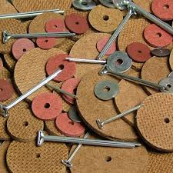
When you want to hold material together (i.e., cardboard, fabric, plastic, etc.) and still be able to move the pieces similar to the should joint of an articulated toy bear, cotter pins, washer and rigid disks are the answer. Please watch this video to see how this can be done. The example in the video is creation of a bear with moveable arms, but you can adapt this tip for use with plastic pipe to make prototype crane and a million other things.
https://www.youtube.com/watch?v=9rW004vw88w

- Substituting brads / fasteners for cotter pins
If the material you are fastening is light weight (i.e., thin cardboard or heavy paper), simple brass-plated fasteners or brads will work. However, they lack the structural integrity of cotter pins and washers and will wear holes in thin materials.
- Hydraulic and pneumatic ideas from Rubber Band Engineer by Lance Akiyama provides amazing structural ways to make hydraulic and pneumatic machines that propel inventions in sustainable ways. The book is well worth the purchase price and Lance’s work should be supported. To wet your curiosity, check out http://www.lancemakes.com/#!engineering-for-kids/tl5tv for downloadable project lessons. The graphic below shows four of the numerous ideas available.

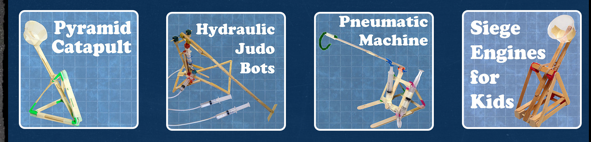

- Pipe cleaners and straws as joinery
Thanks to a display of PITSCO kits at ISTE 2016 in Denver, we learned a simple joinery technique using everyday straws and pipe cleaners. PITSCO’s book, Straw Structures Teacher’s Guide, offers instruction, resources, puzzles, lesson activities http://www.pitsco.com/Straw_Structures_Teachers_Guide. They have kits, resources, and lessons that can be purchased and they are linked to US curriculum standards for STEAM education.

Our biggest learning was the use of a single pipe cleaner, folded three-ways to make a joint capable of connecting three straws and creating a stable corner.

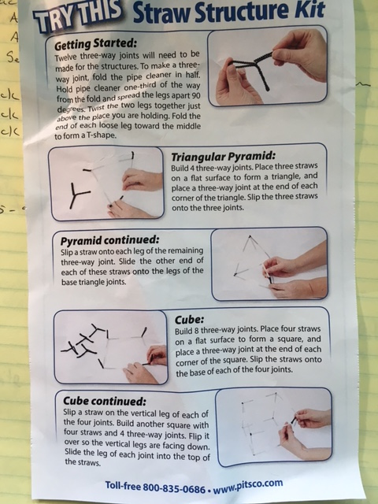

Cardboard fastener Ideas

Participant Group Kits and Shared Pantry Contents for Prototyping During Design Thinking Process
Since the ILC started its work with design thinking, we have worked hard to ensure that the materials and resources used are affordable, accessible and appropriate. We never wanted participants and institutions or groups excluded from making and designing due to assess or cost issues.
Common to the intentions is the use of a Participant Group Kit, Shared Pantry, and Shared Tool Station. We recommend these components to support the design and prototyping process and to ensure participants are supported in making their ideas provoked from the design challenges tangible and shareable.

The Participant Group Kit is used as a disrupter! Design Thinking is fundamentally about divergent, lateral thinking that disrupts designers from rushing to solutions and to engage in human centred thinking that enables problem finding. Once participants have completed their initial design thinking work and before they begin prototyping, we suggest providing them with a Participant Group Kit. You will note that the Design Challenges format offered in Section 3.1 states in the Parameter that the team “Plan how to use something of every consumable item in the Participant Group Kit provided.” We have found that adding this final disrupter into the design process is important. Once again, groups are required to consider their design, ideating and iterating ways in which to use the new resources for best advantage and functionality.

We offer the following suggestions for Participant Group Kits by learning intention. Please note, these are only suggestions and should be modified by availability to materials, budget consideration, recycling / reuse options, culture, location, etc. We also offer a suggestion for tools to support a mobile maker configuration for classrooms.

Suggested Participant Group Kits by Making / Prototyping Intention
Making / Prototyping Intention | Description | Participant Group Kits  - 1 kit for each group of 4 participants  - Quantities of each consumable item are less important as students do not have to use all the items and additional items are available from the Shared Pantry
Design and Basic making | Introduction of design thinking and making simple, tangible items to illustrate design ideas in 3d | - Lunch size brown paper bag to hold content  - Small piece of Hook and Loop Stick-On Strips (common commercial name: Velcro)  - 1-3 meters of jute or string  - Pipe cleaners  - Straws  - Misc coloured paper  - Coloured PomPoms  - Foam pieces / or small piece foam core  - Toothpicks  - Bamboo skewers  - Modeling clay
Design and Simple Prototyping | Introduction and continued use of design thinking and more elaborate prototyping of ideas to scale | - Lunch size brown paper bag to hold content  - Small piece of Hook and Loop Stick-On Strips (common commercial name: Velcro)  - 1-3 meters of jute or string  - Pipe cleaners  - Straws  - Misc coloured paper  - Coloured PomPoms  - Foam pieces / or small piece foamcore  - Toothpicks  - Bamboo skewers  - Modeling clay  - Kitchen garbage size plastic bag  - Marbles  - Springs – small  - Tie Wire (1 meter)  - Wood pieces - Tongue depressor type  - Coloured wooden pieces – craft items  - Zip tie
Design and Fabrication | Use of design thinking and introduction of fabrication to create working prototypes at scale | Same as for Design and Simple Prototpying above

Suggested Shared Pantry by Making / Prototyping Intention

Making / Prototyping Intention | Description | Pantry Items  Complete listing with suggested quantities can be found in Maker Day Toolkit v2 (https://issuu.com/ubcedo/docs/makerdaytoolkitver2revisemay31e/1)
Design and Basic Making | Introduction of design thinking and the making of simple, tangible items to illustrate design ideas in 3d | - Cardboard boxes (recycling or from grocery / appliance stores)  - Cardboard pieces  - Egg cartons – paper and foam  - Magnets (pieces and sheets)  - Modeling clay  - Paper scraps and sheets  - Styrofoam (recycling)  - Tape – duct  - Tape – electrical, coloured and clear  - Fabric  - Misc found and fun items
Design and Simple Prototyping | Introduction and continued use of design thinking and more elaborate prototyping of ideas to scale | - Cardboard boxes (recycling or from big box stores)  - Cardboard pieces  - Egg cartons – paper and foam  - Magnets (pieces and sheets)  - Modeling clay  - Paper scraps and sheets  - Styrofoam (recycling)  - Tape – duct  - Tape – electrical, coloured, clear  - Fabric  - Misc found and fun items  - Irrigation pipe with appropriate fittings  - Doweling – misc sizes
Design and Fabrication | Use of design thinking and introduction of fabrication to create working prototypes at scale | Same as for Design and Simple Prototpying above  - Depending on access to tools, consider dimensional lumber and scrap wood  - Structural materials – pieces of acrylic sheeting, etc.
Design, Prototyping, Circuitry and Coding | Use of design thinking with the addition of coding and circuitry to add functionality to prototypes | - Same as for Design and Simple Prototpying above  - Refer to Coding & Microcontrollers in Design for Ardruino and simple circuit ideas (https://issuu.com/ubcedo/docs/diy_guidebook)  - Also refer to the Ardruino site (http:// playground.arduino.cc/Projects/Ideas) for suggested activities and resources

Suggested Shared Tool Station By Making / Prototyping Intention

Making / Prototyping Intention | Description | Pantry Items  Complete listing with suggested quantities can be found in Maker Day Toolkit v2 (https://issuu.com/ubcedo/docs/makerdaytoolkitver2revisemay31e/1)  Ensure there are adequate power bars available to power tools as required
Design and Basic Making | Introduction of design thinking and the making of simple, tangible items to illustrate design ideas in 3d | - Box cutters (utility knives)  - Glue guns – mini craft size  - Replacement mini glue sticks  - Pencils with erasers  - Felt markers  - Pliers  - Metal rulers  - Scissors  - Measuring tape
Design and Simple Prototyping | Introduction and continued use of design thinking and more elaborate prototyping of ideas to scale | - Box cutters (utility knives)  - Glue guns – mini craft size  - Replacement mini glue sticks  - Pencils with erasers  - Felt markers  - Pliers  - Metal rulers  - Scissors  - Measuring tape  - Drywall straight edge  - Hand held Dremel tool  - Dremel tool  - Dremel Rotary Tool Work Station  - Dremel Flex Shaft Attachment  - Dremel tool accessories (bits, etc.)  - Hand saw  - Small drill – battery powered  - Wooden V blocks with clamps (turns almost all flat surfaces into a vise for holding items to be cut or drilled)
Design and Fabrication | Use of design thinking and introduction of fabrication to create working prototypes at scale | Same as for Design and Simple Prototyping above  - Depending on materials and technical support, consider chop saw and other power tools
Design, Prototyping, Circuitry and Coding | Use of design thinking with the addition of coding and circuitry to add functionality to prototypes | Same as for Design and Simple Prototyping above  - Soldering iron  - Flux  - Sphero  - littleBits  - Lily pad ardruino – fabric and sewing supplies

Mobile Maker Kit (Suitable for 40 participants)

Kit Items  (alphabetical) | Quantity | Notes
Rolling suitcase or toolbox | 1 | This container needs to hold all the kit items and able to be secured. Mobile toolboxes often have fasteners that allow for locks and a chain to secure them when they are not use.
Clamps, Rachet | 2 | 6” – 150 mmm Quick Racheting Bar Clamp — Used to make cutting safer; use with a v block to hold round material
Clamps, Ratchet | 3 | Used to make cutting safer; use with a v block to hold round material
Dremmel Kit (optional, depending on budget & site) | 1 | Dremmel or Dremmel-like tools offer numerous attachments for cutting, drilling, sanding options. The tool is small, easy to use, and accessible for reluctant tool users
Drill bits | 1 Kit | Various sizes — IF possible, Keep in Drill Kit
Drill, Cordless Electric ((optional, depending on budget & site) | 1 | Basic battery powered, light weight drill
First Aid Kit | 1 | Basic Kit
Glue Gun, Mini | 4 | Lower heat and longer to heat up — Used for tongue depressors, etc.
Mini Glue sticks | 1 pkg | Refills
Glue Gun, Rapid heat | 1 | Heats faster and hotter than mini glue guns — Used for Doweling, Plastic, Metal
Glue Gun, Rapid heat sticks | 1 package | Refills
Hammer | 1
Pliers | 1 | Preferred: Needle Nose with wire cutter
Pliers | 4 | Preferred: Needle Nose with wire cutter
Power Bar | 1 | Preferably 6 foot reach and at least 6 plug-ins
Rulers, 12” | 5 | Recommend: Steel rulers to use with utility box cutters
Saw, Fine-tooth hand | 3 | Folding pruning saw also works well
Saw, Hack | 2 | Easier to cut with than wood saws
Scissors | 5 | Preferred: various sizes/functions
Squares, Quick Angle | 5 | Good for complex mathematics measuring and angle cuts
Tape Measure | 5 | 12 foot is adequate
Utility box cutters | 5 | Some come with refillable blades in the handle

Appendix 2 – Sample Design Challenges

The sample design challenge provided here are based on work done in western Canada. They do not presume to reflect the South African context in which this research project is situated, but they do provide a model from which we might create more appropriate challenges. They follow the ILC Design Challenge structure shared in Section 3 - Components of a Good Design Challenge
The first sample design challenge builds on the research question shared in Section 2.2 Using Design Thinking for Research. As stated in that section, the design thinking process typically starts with a real-world challenge. Rather than hurrying to find a quick solution or trying to immediately replicate generalized solutions, the design thinking process is used to find and identify the source of the challenge by engaging with the people experiencing it and experiencing the factors that created it.

The complex or wicked problem informing this design challenge is

How might understanding the components of a healthy meal assist families in preparing and eating foods that support active, healthy living? Further, what barriers do families in extreme poverty face in attempting to prepare and consume meals that support active, healthy living?

Below is an annotated version of a design challenge. The Component Description column offers a meta description of the purpose of the component.

Sourcing, Preparing and Serving a Healthy Meal

Design Challenge Component | Component Description | Example  Designing A Healthy Lunch Experience
Overview | Introduction to the challenge to provide an authentic learning context or situation. | Making our own meals on a regular basis saves money and helps us to eat healthier. But like other healthy things (e.g. exercise, personal wellness, time management, etc.), we often lose our way and forget to make the time it takes to do what is best for us. Sometimes we forget what a healthy meal even looks like!
Design Rationale | Short explanation of why the challenge is in fact a challenge worth addressing and links participants’ prior learning while also providing links to new information.  Resources and sources to guide initial inquiry work can be positioned here. | In a busy world of life balance, work, and the ever increasing cost of good food, we need to pause and consider what might be a healthy and sustainable meal.  The website (http://lifehacker.com/pack-healthy-hearty-lunches-with-this-six-layer-formul-1752826181) offers an interesting formula to help us to have a balanced, delicious meal experience.  Central to the formula is the notion of a six-component meal which consists of the following elements:  Grains: Anything from rice to quinoa, this will act as the foundation of your meal and be integral to staying full the whole afternoon. Obviously optional if you’re watching your carbs.  Seasonal vegetable: You can throw in more than one veggie, whichever ones you happen to have on hand or is fresh in the garden or market.  Leafy greens: Raw or cooked, greens will bulk up your meal, and if you’re cutting out grains or watching your carbs, switch these out as the base of your meal for a fibrous, healthy alternative.  Protein: Tons of ways you can go here, from sliced chicken, cured meats, tofu cubes, beans, or a hard boiled egg.  Sour/acidic flavor: Lighten things up and pulls your dish together with an acidic dressing, sauce, or even just a squeeze of lemon.  Healthy fats: This is your chance to really customize each day’s meal, from olive oil to avocado to nuts.  Of concern is how to source, prepare and serve good, meals, and keep a balance of how much of each component is necessary for a healthy diet.
Problem Scenario | Paragraph inviting participants into the challenge and explaining the role / reason for their group’s involvement in addressing the problem | Your team has been selected to develop the perfect tool that addresses the problems we face in sourcing, preparing and serving a healthy meal. Currently, many of us grab quick take away meals without considering other ways we might prepare or supplement existing food. Your task is make a local solution to this problem.
Success Determinants | Usually begins with “Success Will Be Determined By Degree To Which Your Design Solution:” followed by criteria assessment using suggested characteristics / attributes that constitute a good design solution for the challenge | - Addresses the design challenge  - Addresses an identifiable need  - Uses the provided materials, resources, and tools  - Is a helpful and unique options for those of us considering sourcing, preparing and serving healthy meals.
Parameters | Specific issues, constraints or limiting factors impacting the participants and should address (i.e., rules, limitations) for the group to negotiate. | - Plan how to use something of every consumable item in the Participant Group Kit provided  - Choose consumable items and materials found in the Shared Pantry to aid in the enhanced development of your group’s prototype  - Use the tools that have been provided at the Shared Tool Station

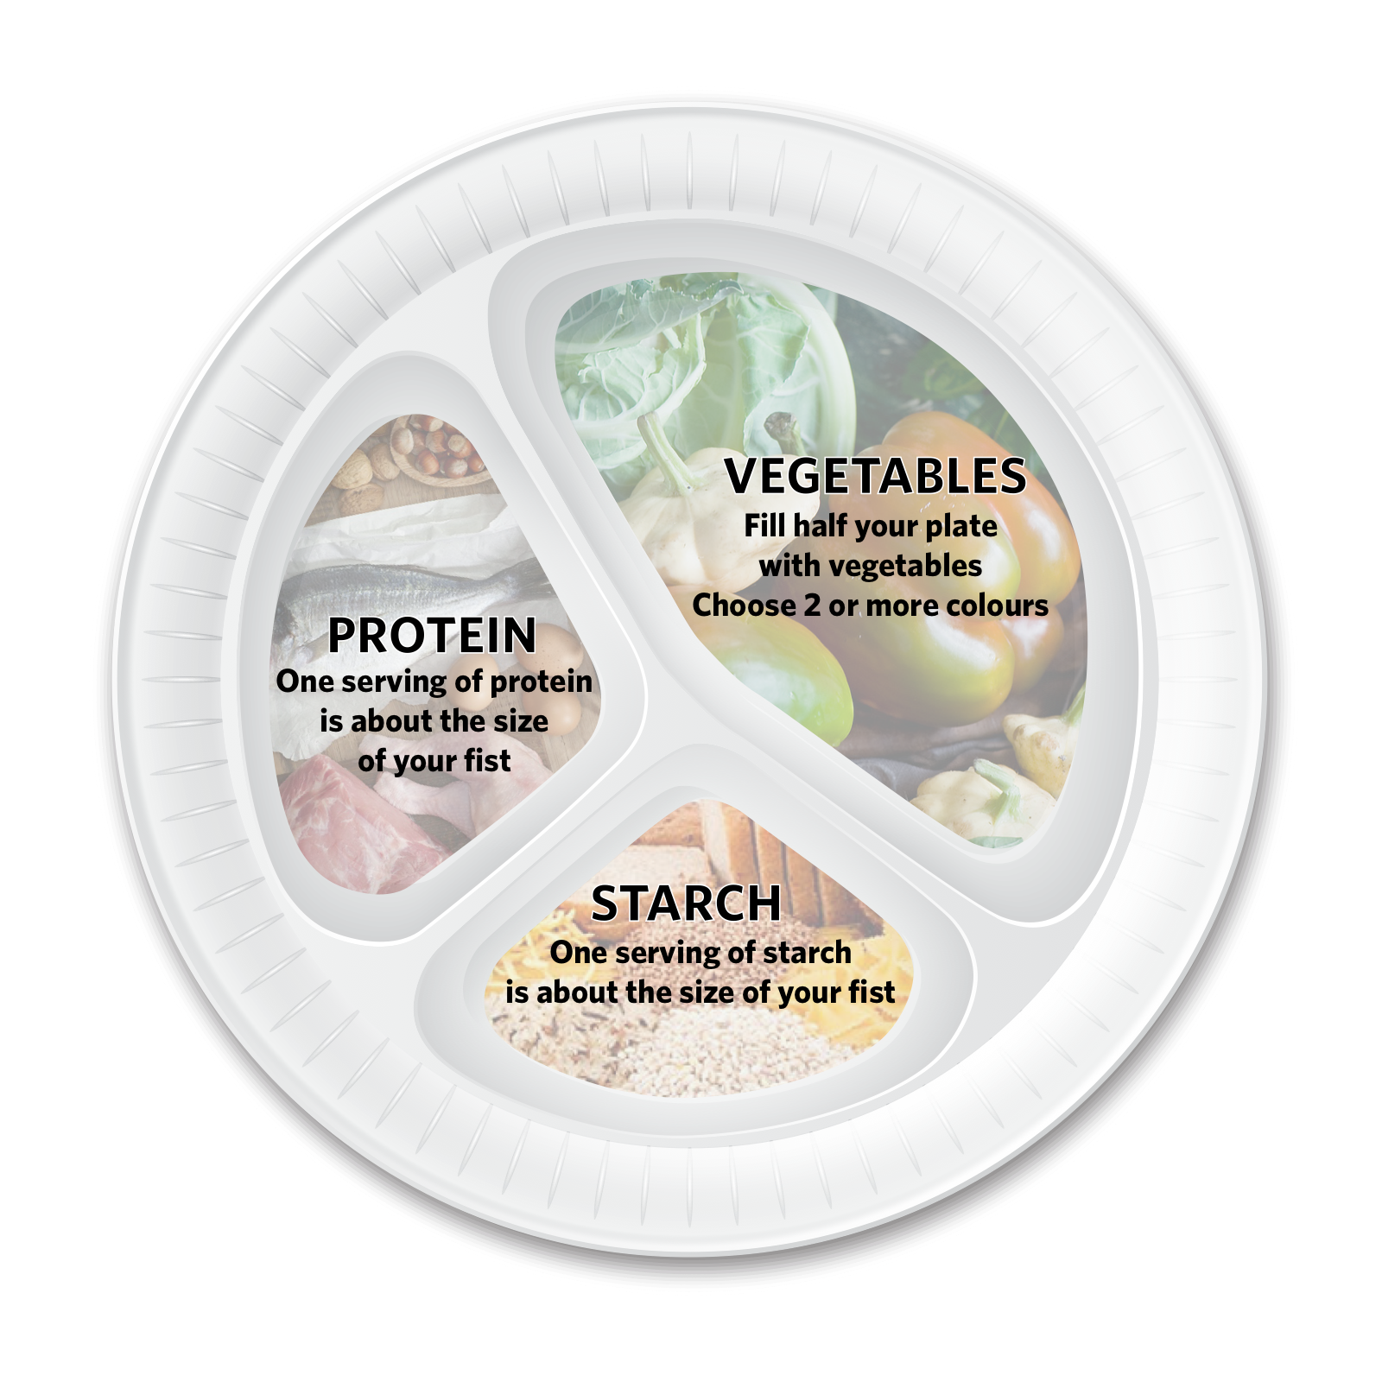
A fun solution to the Healthy Meal Challenge is Fun Food Frisbee. As it thought about our research question, I wondered if people needed a tool to help them visualize healthy quantities of various food types. Nutrition research in Canada suggests half of a person’s plate such be filled with vegetables while the other half should be split between healthy starch and protein. The Frisbee can be used a plate and also as a tool for active play.

A well-crafted design challenge fosters heads-in (content); hearts and minds open (empathy, curiosity and purpose); hands-on (skill sets) and creates rich, multidimensional / multimodal / multimedia opportunities for participants to demonstrate what they know and how they came to know it in deep and personal ways. It promotes divergent thinking and offers a creative, open and fun way to share information and build new thinking together. For example, Designing a Healthy Meal works well because it positions making in the aid of good thinking and deep understanding of the complex problem of why the majority of people do not get adequate nutrition during a day, and it might even begin to address the wicked problem of affordable food, obesity and/or wellness.

Appendix 3 - Tips for Facilitating a Design Thinking Research Session

The tips assume you already have a research question that is written in the form of a design challenge (see Section 3 and Appendix 2 – Sample Design Challenges).

Before You Start the Design Thinking Process

- Prepare design challenge and obtain materials (A4 paper, pencils, erasers, pencil sharpeners, tools and materials for prototyping)

- Organize your participants into groups of 4.

- Introduce participants to the design challenge. Explain they will be facilitated through a series of timed activities. Assure the participants there may be activities that seem way too long or way too short. Ask everyone to save their questions about the process until after it is completed. For now, tell them to relax and trust the process.

- Give each participant a piece of A4 paper, a sharpened pencil, and eraser. Ask them to fold the paper into 4 parts and number the parts 1-4. Have extra sheets of paper, pencils and if possible, a pencil sharpener available to the participants.

1. | 2.
3. | 4.

- Ask each pair to identify who will be Participant A and who will be Participant B. Before starting, ask Participant A’s to raise their hands. Thank them. Then ask Participant B’s to raise their hands. Thank them. This gives you a quick way to ensure everyone heard your instructions, has made a choice, and is ready to start.

Facilitator Steps for Leading a Participator Design Thinking Research Session
(Please note, these steps are generic and the research questions were written in Canada without knowing the South African context in which we will be working. These steps and the example research questions will probably need to be rewritten to reflect the actual context of the work with the support of our community members.)

- Instructions for Part #1: Empathy
Learning about your partner’s perspectives and knowledge

Guiding Questions: What are the components of a healthy meal? What are the barriers to eating nutritious food and living a more active, nutritious lifestyle?

Participant A will have 3 minutes to listen as Participant B responds to the general questions. Participant A will record Participants B’s responses in Part #1. Remind Participants they may need to ask additional powerful, open ended questions as prompts.

Start timing. Once the time is over, remind Participant As to add any additional notes on their sheet in #1.

Switch roles: Participant B will have 3 minutes to listen to and question Participant A using the same general questions and any additional powerful, open-ended questions as prompts. Remind Participant Bs to record the responses on their sheets in #1.

Start timing. Once the time is over, remind Participant Bs to add any notes on their sheet in #1.

- Instructions Part #2: Define Challenges
Learning about your partner’s experiences and contexts

Guiding Question: How might we help families overcome the barriers they face?

Participant A will have 3 minutes to listen and prompt with powerful, open-ended questions as Participant B responds to the question. Participant A records Participant B’s responses in Part #2.

Start timing. Once the time is over, remind Participant As to write additional notes on their sheet in #2.

Switch roles and ask Participant B to listen and prompt with powerful, open-ended questions as Participant A responds to the question. Participant B records Participant A’s responses in Part #2.

Start timing. Once the time is over, remind Participant Bs to write additional notes on their sheet in #2.

- Instructions for Part #3: Define Evidence
Asking your partner to describe how their past experiences and learning have informed the challenges they have described

Guiding Question: How do you know this?

Participant A will have 2 minutes to listen and prompt as Participant B responds to the question.

Start timing. Once the time is over, remind Participant As to write additional notes on their sheet in #3.

Switch roles and ask Participant B to listen and prompt as Participant A responds to the question. Participant B records Participant A’s responses in #3.

Start timing. Once the time is over, remind Participant Bs to write some notes on their sheet in #3.

- Instructions for Part #4: Ideate
Asking your partner to form creative solutions to address their unique challenges

Guiding Question: How might you or your institution address those challenges?

Participant A will have 3 minutes to listen and prompt as Participant B responds to the question.

Start timing. Once the time is over, remind Participant As to write additional notes on their sheet in #4.

Switch roles and ask Participant B to listen and prompt as Participant A responds to the question. Participant B records Participant A’s responses in #3.

Start timing. Once the time is over, remind Participant Bs to write additional notes on their sheet in #4.

- Instructions for Part #5: Prototype
Asking participants to work individually to create a prototype of a possible solution

Ask Participants to turn their papers over. Ask the Participants to divide their paper into half numbering one half #5 and the second half #6

5. | 6.

Guiding Question: After reviewing all your notes and reflecting on all the information you and your partner have created, what resources or supports could you develop to support more nutritious eating and active living? How would your resource or supports address at least one of the challenges you and your partner discussed?

Before starting, review the Design Challenge. Remind participants the definition of a prototype as a representation of one or more ideas to show how you might begin to solve the design challenge.

Participants will be given 5 minutes to answer the guiding questions individually. Ask Participants to describe, using words and / or drawings, how they would begin to develop and design a quality resource that could support active learning and foster a growth and intentional mindset in your students.

Start timing.

- Instructions for Part #6: Test
Asking another participant to be your critical friend as you describe your resource

Ask Participants to share their ideas with a Participant in the room that was not their Partner for Parts 1-4. Remind the participants to write down any additional ideas or questions their critical friend surfaces. Ensure that both participants have time to present and receive feedback. Remind everyone to have some notes in #6.

Before starting, remind Participants what it means to be a Critical Friend.
  - Ask open questions
  - Give constructive feedback
  - Offer supportive ideas
  - Use “and” rather than “but” when offering feedback

If time allows, have the original partners met to go over their solutions and feedback.

Much of the content in this resource has been previously published in the toolkits (https://innovativelearningcentre.ca/about/ilc-publications/) created by the Innovative Learning Centre at UBC Okanagan (https://innovativelearningcentre.ca/)

